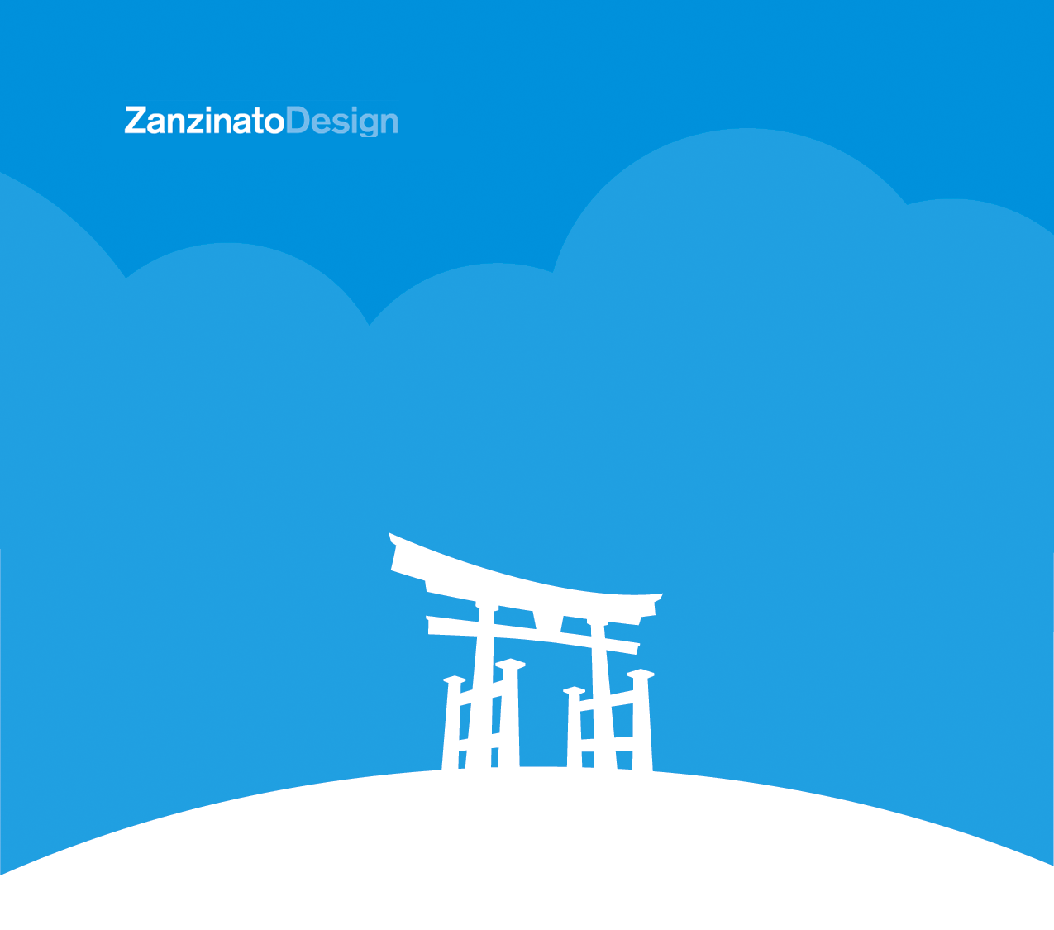

ProjectPlanner
Thanks for getting in touch with us. The responses we collect from this project sheet will give us the information we need to create an accurate estimate for your project. Please answer the questions to the best of your ability and with as much detail as possible. Skip any questions that don’t apply to your project. When you’re finished, please upload it to the web form on our contact page, or email it to hello@zanzinato.com.

We look forward to learning more about your company and project!

General Information

What is the name of your company?

Are you the primary contact from your organization? If not, who is?
Name, E-mail, and Telephone if possible

Describe your business and the products or services you provide.

Who are your customers?

Who are your current competitors?

Do you have an existing brand? If so, do you have guidelines?

Will your project require a new logo or other branding?

Please describe your project.

What are your objectives or goals in undertaking this project?

What is the project timeframe? Is it being developed for a specific date or event?

Please give us a general idea of your budget.
This will help us put together a custom plan tailored to your budget

Web Project

What is your current or desired domain name?

Tell us about what you’re looking for on your web project. What important messages do you want to get across?

Why will people visit your site? Describe the user.

Have you thought about the site structure?

Will we be using any existing content? Will you require assistance creating or editing content and securing photography?

How would you describe the desired look and feel you would like to achieve? Please share with us any other ideas you have in mind.

Are there other sites you admire? Why?

What are the URLs of some of your competitors’ sites?

Are you currently using a content management system?

Who will be responsible for maintaining the site after launch?

Will you require hosting services?

Are there any special requirements we should be aware of or additional details you would like to share with us?

Print Project

What is the format of the piece? Is it a brochure, flyer, poster, booklet, media kit, tradeshow graphic, or something else?

What is your objective in creating this piece?

What is the specific message are you trying to communicate? Will there be a call
to action?

Are you updating existing materials or are you looking to refresh your image with this new piece?

Do you have any old promotional materials for us to review?

Who is your target audience?

What content will be included in this piece?

Who will be providing the copy and photography? Will you need help creating content and securing photography?

What is your printing budget for this project? This will let us know if there are limitations we’ll need to consider in creating the design.

Are there any other details you feel would be helpful for us?

